**Lecture 28: Introduction to E-Commerce**

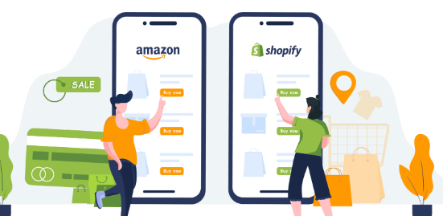

**1. Definition and Components of E-Commerce**

**What is E-Commerce?** E-commerce, or **electronic commerce**, refers to the process of buying and selling goods and services online. It includes all activities involved in the commercial transaction that occurs over the internet. E-commerce has become an essential part of modern business, enabling companies to reach a global audience and conduct business efficiently through digital platforms.

**Components of E-Commerce**:

E-commerce is made up of several key components that work together to facilitate online transactions. These include:

1. **Online Stores (Websites and Apps)**:
   * These are digital platforms where businesses sell their products or services to customers.
   * Examples: **Amazon**, **Flipkart**, **eBay**.
2. **Payment Systems**:
   * Online payments are an essential part of e-commerce. Businesses use secure payment gateways to process payments made by customers.
   * Examples of payment systems: **PayPal**, **Stripe**, **Google Pay**, **Credit/Debit Cards**.
3. **Online Marketing**:
   * This involves strategies to promote products and services online, such as search engine optimization (SEO), email marketing, and social media campaigns.
   * Example: **Amazon** uses targeted ads and personalized emails to promote products to its users.
4. **Logistics and Delivery**:
   * Once the transaction is made, the product needs to be delivered to the customer. This involves a network of couriers, warehouses, and other logistical operations.
   * Example: **Amazon** uses its own delivery network and partners with delivery services to ensure quick deliveries.
   * In this context, logistics refers to the planning, execution, and management of the flow of products from the point of origin (like a warehouse) to the final destination (the customer's location). This includes coordinating transportation, warehousing, inventory management, and order fulfillment processes. Effective logistics ensures that products are delivered efficiently and on time, optimizing costs and improving customer satisfaction. In the example of Amazon, their logistics involve not just their own delivery network, but also partnerships with third-party couriers to enhance delivery speed and reliability.
5. **Customer Service**:
   * E-commerce businesses need systems to address customer queries, complaints, and feedback. These can include live chat support, emails, and phone services.
   * Example: **Zappos**, a popular online shoe retailer, is known for its excellent customer service, offering free returns and 24/7 support.

**2. Evolution of E-Commerce**

E-commerce has gone through significant changes over the years, evolving from basic online transactions to a vast, interconnected ecosystem involving multiple technologies and business models. Let's explore this evolution:

1. **Early Stages (1990s)**:
   * The **1990s** marked the beginning of e-commerce, primarily through basic websites where businesses began offering their products online.
   * In **1994**, the first online transaction was made through **NetMarket**, an early e-commerce website, selling a Sting album.
   * **Amazon** and **eBay** were founded in the mid-1990s. Amazon initially started as an online bookstore in 1994, and eBay was launched in 1995 to facilitate online auctions.

**Example**: **Amazon** began as a small online bookstore, but quickly diversified its products and grew into one of the largest e-commerce platforms globally.

1. **The Rise of Online Shopping (2000s)**:
   * The **2000s** saw significant improvements in internet speeds, security, and the development of e-commerce-specific technologies, which led to the growth of online shopping.
   * Payment systems like **PayPal** were introduced in 1998, making it easier for people to buy products online securely.
   * **Alibaba**, the Chinese e-commerce giant, was founded in 1999, and it quickly expanded, becoming a leader in global online sales.

**Example**: **PayPal** revolutionized online payments by providing an easy-to-use, secure method for transactions, enabling millions of people to buy goods online without directly sharing their credit card information.

1. **The Mobile Revolution (2010s)**:
   * With the widespread adoption of smartphones, e-commerce experienced another growth phase. **Mobile commerce (m-commerce)** emerged as people could shop, pay, and track deliveries from anywhere at any time.
   * E-commerce businesses began developing mobile-friendly websites and apps to cater to the growing number of mobile users.
   * Social media platforms, like **Instagram** and **Facebook**, also became important marketing channels for businesses, and **social commerce** emerged, allowing users to purchase directly from social media.

**Example**: **Instagram Shopping** allowed users to directly purchase products through the app, turning social media into a shopping platform.

1. **The Age of Artificial Intelligence and Personalization (2020s)**:
   * **AI and machine learning** are now playing a crucial role in e-commerce, providing personalized shopping experiences by recommending products based on previous behavior or preferences.
   * Voice shopping through virtual assistants like **Alexa** and **Google Assistant** has gained popularity, allowing customers to make purchases simply by speaking.
   * Additionally, **augmented reality (AR)** is allowing consumers to virtually "try on" products like clothes or makeup before purchasing.

**Example**: **Amazon** uses AI and machine learning to suggest products based on past purchases and search history. **Sephora** uses augmented reality (AR) through its app, allowing customers to see how makeup products would look on their faces before purchasing.





**3. Key Players in the E-Commerce Ecosystem**

The e-commerce ecosystem involves multiple players, each playing an important role in making online transactions possible and efficient. Here’s a breakdown of the key players:

1. **E-Commerce Platforms**:
   * These are the websites or apps where transactions take place. They allow businesses to showcase and sell their products or services.
   * Examples: **Amazon**, **Alibaba**, **Etsy**, **Flipkart**.
2. **Payment Gateways**:
   * Payment gateways are services that securely process payments from customers to businesses. They ensure that payment details are encrypted and transferred safely.
   * Examples: **PayPal**, **Stripe**, **Razorpay**, **Google Pay**.
3. **Logistics Providers**:
   * These players handle the delivery of goods from the seller to the buyer. They manage warehouses, shipping, and returns.
   * Examples: **DHL**, **FedEx**, **BlueDart** (India), **Delhivery** (India).
4. **Sellers and Merchants**:
   * These are the businesses or individuals who sell products or services through e-commerce platforms. They may operate large online stores or small boutique businesses.
   * Examples: **Nike**, **Apple**, **Small independent boutiques on Etsy**.
5. **Customers**:
   * Customers are the buyers who engage in the e-commerce transaction by purchasing products or services.
   * Example: Everyday shoppers like you and me who buy products from **Amazon**, **Myntra**, or **Flipkart**.
6. **Third-Party Service Providers**:
   * These are companies that offer additional services to enhance the e-commerce experience. These can include marketing services, inventory management, customer support, and more.
   * Examples: **Shopify** (helps businesses set up their online stores), **Zendesk** (provides customer service software), **HubSpot** (CRM software).



**Case Study: Amazon – A Global E-Commerce Giant**

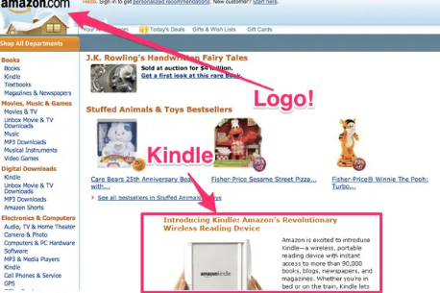

**Background**: Founded in 1994 by Jeff Bezos, **Amazon** started as an online bookstore. Today, it is the world's largest online retailer, selling everything from books and electronics to clothing and groceries. It operates in more than 20 countries and serves millions of customers worldwide.

**Key Factors for Success**:

1. **Wide Product Range**: Amazon offers millions of products, catering to almost every customer need, from books to electronics to groceries.
2. **Prime Membership**: Amazon introduced **Amazon Prime**, offering free two-day shipping, access to movies, TV shows, and other benefits, making it extremely popular with customers.
3. **Innovative Technology**: Amazon was one of the first companies to implement machine learning algorithms to personalize product recommendations, increasing sales and customer satisfaction.

**Challenges**:

1. **Competition**: Amazon faces tough competition from companies like **Alibaba** and **Walmart**, especially in markets like China.
2. **Logistics**: As it grows, Amazon has to manage a complex global supply chain and logistics network to meet customer expectations for fast delivery.

**Future Directions**:

* **Artificial Intelligence and Robotics**: Amazon is increasingly using AI and robotics in its warehouses to speed up the sorting and shipping process, improving efficiency.
* **Cloud Computing**: Through **Amazon Web Services (AWS)**, Amazon provides cloud storage and computing services to businesses, becoming a major player in the cloud computing industry

